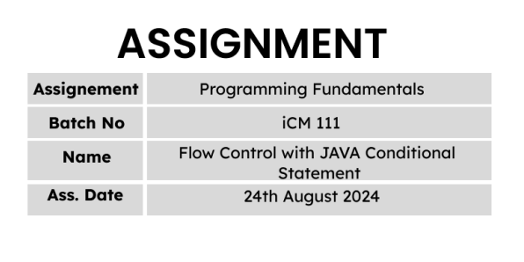

==================================Q 1 ========================================

import java.util.*;

class Example{

public static void main(String args[]){

Scanner input = new Scanner(System.in);

System.out.print("Enter number 1 : ");

int num1 = input.nextInt();

System.out.print("Enter number 2 : ");

int num2 = input.nextInt();

if(num1 > num2){

int total = num1 + num2;

System.out.printf("%d + %d = %d\n",num1, num2, total);

}else{

System.out.println(num1 + " " + num2);

}

}

}

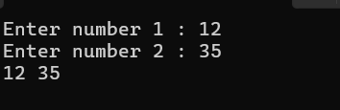

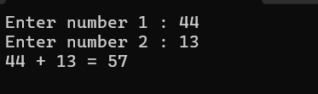

==================================Q 2 ========================================

import java.util.*;

class Example{

public static void main(String args[]){

Scanner input = new Scanner(System.in);

System.out.print("Enter an integer number : ");

int num = input.nextInt();

if(num >= 0){

System.out.println("Absolute number = " + num);

}else{

int absolute_value = -(num);

System.out.println("Absolute number = " + absolute_value);

}

}

}

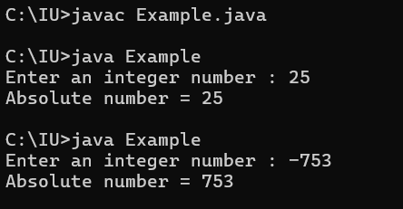

==================================Q 3 ========================================

import java.util.*;

class Example{

public static void main(String args[]){

Scanner input = new Scanner(System.in);

System.out.print("Enter the marks of Chemestry : ");

int chem_marks = input.nextInt();

System.out.print("Enter the marks of Physics : ");

int phy_marks = input.nextInt();

System.out.print("Enter the marks of Combined Maths : ");

int math_marks = input.nextInt();

double average = (chem_marks + phy_marks + math_marks) / 3;

if(average >= 75){

System.out.println("Pass");

}else{

System.out.println("Fail");

}

}

}

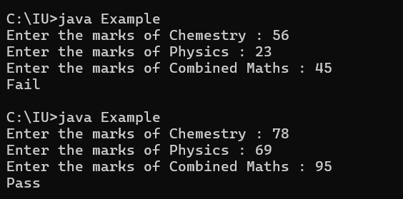

==================================Q 4 ========================================

import java.util.*;

class Example{

public static void main(String args[]){

Scanner input = new Scanner(System.in);

System.out.print("Enter the unit price : ");

int unit_price = input.nextInt();

System.out.print("Enter the amount of product : ");

int amount = input.nextInt();

int total = unit_price * amount ;

if(total > 1500){

System.out.println("You are entitled to the super draw !!!");

}else{

System.out.println("Try again !");

}

}

}

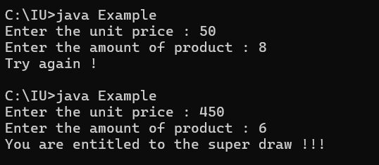

==================================Q 5 ========================================

import java.util.*;

class Example{

public static void main(String args[]){

Scanner input = new Scanner(System.in);

System.out.print("Enter the unit price : ");

int unit_price = input.nextInt();

System.out.print("Enter the amount of product : ");

int amount = input.nextInt();

int total = unit_price * amount ;

if(total > 500){

double discount = total * 0.05;

double net_total = total - discount;

System.out.printf("Discount = %.2f\nTotal = %.2f",discount, net_total);

}else{

System.out.println("No discount given.");

System.out.printf("Total = %d",total);

}

}

}

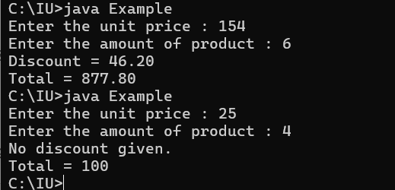

==================================Q 6 ========================================

import java.util.*;

class Example{

public static void main(String args[]){

Scanner input = new Scanner(System.in);

System.out.print("Enter the year : ");

int year = input.nextInt();

if(year % 4 == 0){

System.out.printf("%d is a leap year",year);

}else{

System.out.printf("%d is not a leap year",year);

}

}

}

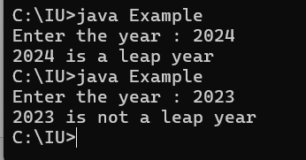

==================================Q 7 ========================================

import java.util.*;

class Example{

public static void main(String args[]){

Scanner input = new Scanner(System.in);

System.out.print("Enter number 1 : : ");

int num1 = input.nextInt();

System.out.print("Enter number 2 : ");

int num2 = input.nextInt();

System.out.print("Enter number 3 : ");

int num3 = input.nextInt();

if(num1 > num2 & num1 > num3){

System.out.printf("Maximum number is: %d",num1);

}else if(num2 > num1 & num2 > num3){

System.out.printf("Maximum number is: %d",num2);

}else{

System.out.printf("Maximum number is: %d",num3);

}

}

}

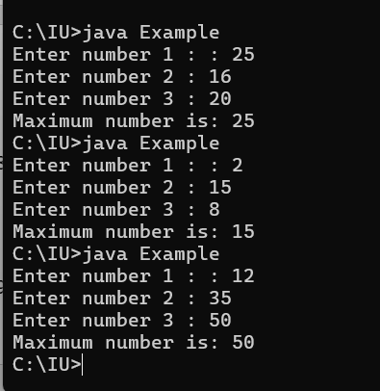

==================================Q 8 ========================================

C & E & F

==================================Q 9 ========================================

All the lines are legally

==================================Q 10 ========================================

import java.util.*;

class Example{

public static void main(String[] args) {

Scanner input =new Scanner(System.in);

System.out.print("Input an integer number : ");

int num = input.nextInt();

if (num % 2 == 0){

System.out.printf("%d is a even number",num);

}else{

System.out.printf("%d is a odd number", num);

}

}

}

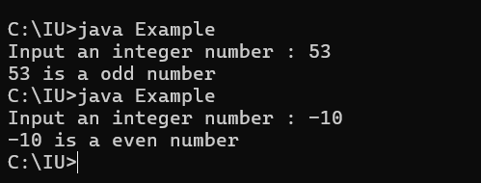

==================================Q 11 ========================================

1. true
2. true
3. true
4. false
5. true
6. false
7. true

==================================Q 12 ========================================

1. 9
2. false
3. true
4. false
5. true

==================================Q 13 ========================================

Line 1 – 10

Line 2 – true

Line 3 – compile error

Line 4 – true

Line 5 – true

Line 6 - false

==================================Q 14 ========================================

Line 1 – 2351.521.231ctrue

Line 2 – 101001251.521.231ctrue

Line 3 – 356.731true

Line 4 – error

Line 5 - error

==================================Q 15 ========================================

Line 1 – true

Line 2 – false

Line 3 – true

Line 4 – false

Line 5 – true

Line 6 – false

Line 7 - false

==================================Q 16 ========================================

1. 1 2 3
2. 2 3
3. 3
4. 4 1 2 3
5. 4 1 2 3
6. 4 1 2 3

==================================Q 1 7========================================

D

==================================Q 18 ========================================

A.Line 1

B.Line 2

C.Line 3

D.Line 4

E.Line 5

F.Line 6

H.Line 8

==================================Q 19 ========================================

1. 1
2. 2 3 1
3. 3 1
4. Wrong
5. Wrong
6. Wrong

==================================Q 20 ========================================

import java.util.*;

class Example{

public static void main(String[] args) {

Scanner input = new Scanner(System.in);

System.out.print("Enter an integer : ");

int number = input.nextInt();

if (number == 0){

System.out.println("You entered zero!");

}else if (number > 0){

System.out.printf("%d is a positive number.",number);

}else{

System.out.printf("%d is a negative number.",number);

}

}

}

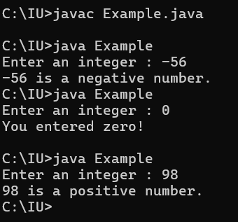

==================================Q 21 ========================================

import java.util.*;

class Example{

public static void main(String args[]){

Scanner input = new Scanner(System.in);

System.out.print("Input number 1 : ");

int num1 = input.nextInt();

System.out.print("Input number 2 : ");

int num2 = input.nextInt();

int difference = num1 - num2;

int abs_difference = 0;

if (difference < 0){

abs_difference = difference * (-1);

}else{

abs_difference = difference;

}

System.out.printf("\nAbsolute difference = %d\n",abs_difference);

}

}

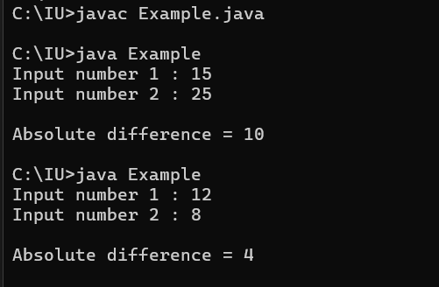

==================================Q 22 ========================================

A , B, C, D, E

==================================Q 23 ========================================

import java.util.*;

class Example{

public static void main(String[] args) {

Scanner input = new Scanner(System.in);

System.out.print("Enter number 1 : ");

int num1 = input.nextInt();

System.out.print("Enter number 2 : ");

int num2 = input.nextInt();

if (num1 == num2){

System.out.println("Both are equal.");

}else if (num1 < num2){

System.out.println("The first number is less than the second number.");

}else{

System.out.println("The first number is greater than the second number.");

}

}

}

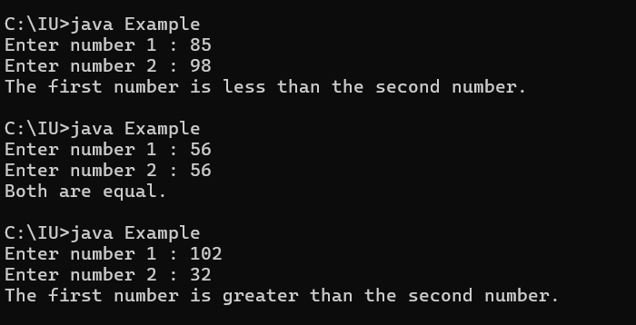

==================================Q 24 ========================================

import java.util.*;

class Example{

public static void main(String[] args) {

Scanner input = new Scanner(System.in);

System.out.print("Enter number 1 : ");

int num1 = input.nextInt();

System.out.print("Enter number 2 : ");

int num2 = input.nextInt();

System.out.print("Enter number 3 : ");

int num3 = input.nextInt();

float num1_right_digit = num1 % 10 ;

float num2_right_digit = num2 % 10 ;

float num3_right_digit = num3 % 10 ;

if (num1_right_digit == num2_right_digit | num1_right_digit == num3_right_digit | num2_right_digit == num3_right_digit){

System.out.println("true");

}

}

}

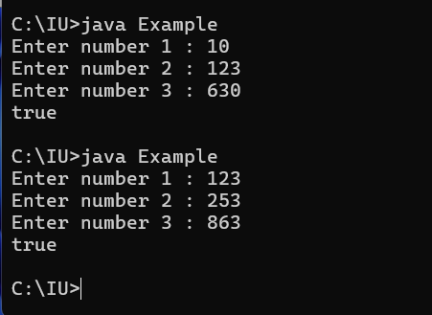

==================================Q 25 ========================================

import java.util.*;

class Example{

public static void main(String[] args) {

Scanner input = new Scanner(System.in);

System.out.print("Enter number 1 : ");

int num1 = input.nextInt();

System.out.print("Enter number 2 : ");

int num2 = input.nextInt();

System.out.print("Enter number 3 : ");

int num3 = input.nextInt();

int difference1 = num1 - num2 - num3 ;

int difference2 = num2 - num1 - num3 ;

int difference3 = num3 - num2 - num1 ;

if (difference1 > 0 || difference2 > 0 || difference3 > 0){

System.out.println("true");

}else{

System.out.println("false");

}

}

}

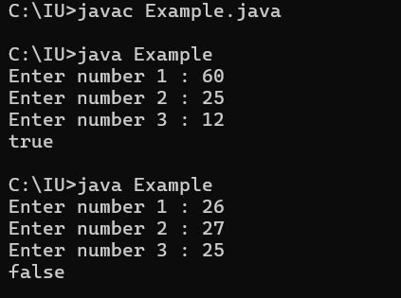

==================================Q 26 ========================================

import java.util.*;

class Example{

public static void main(String[] args) {

Scanner input = new Scanner(System.in);

System.out.print("Input the selling price : ");

double price = input.nextDouble();

System.out.print("Input the cost of the product : ");

double cost = input.nextDouble();

double profit = price - cost ;

if (profit == 0){

System.out.println("No Profit No Loss");

}else if (profit > 0){

System.out.println("Profit");

}else{

System.out.println("Loss");

}

}

}

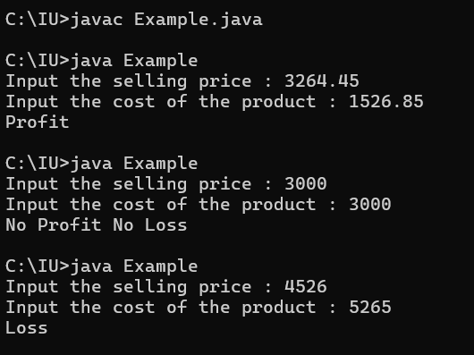

==================================Q 27 ========================================

import java.util.*;

class Example{

public static void main(String[] args) {

Scanner input = new Scanner(System.in);

System.out.print("Input number 1 : ");

int num1 = input.nextInt();

System.out.print("Input number 2 : ");

int num2 = input.nextInt();

System.out.print("Input number 3 : ");

int num3 = input.nextInt();

if (num1 < num2 & num2 < num3){

System.out.println("Increasing");

}else if (num1 > num2 & num2 > num3){

System.out.println("Decreasing");

}else{

System.out.println("Neither increasing nor decreasing order");

}

}

}

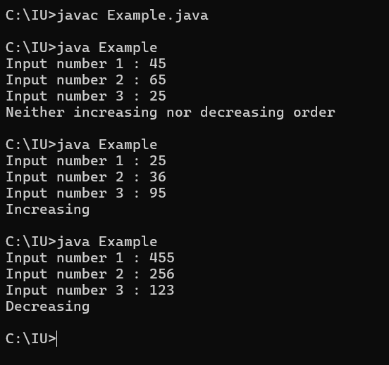

==================================Q 28 ========================================

import java.util.*;

class Example{

public static void main(String[] args) {

Scanner input = new Scanner(System.in);

System.out.print("Enter the age : ");

int age = input.nextInt();

System.out.print("Enter the weight in kilograms : ");

double weight = input.nextDouble();

if (age >= 18 & weight > 50){

System.out.println("Eligible for blood donation");

}else{

System.out.println("Not eligible for blood donation");

}

}

}

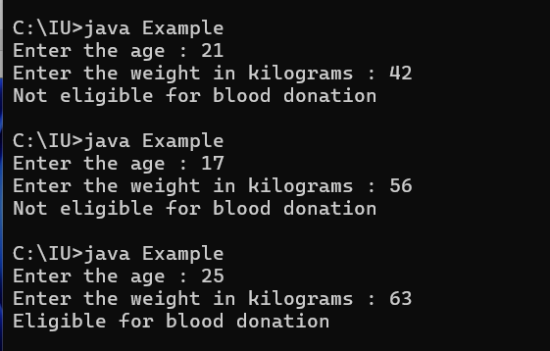

==================================Q 29 ========================================

import java.util.*;

class Example{

public static void main(String[] args) {

Scanner input = new Scanner(System.in);

System.out.print("Enter number 1 : ");

int num1 = input.nextInt();

System.out.print("Enter number 2 : ");

int num2 = input.nextInt();

if (num1 != 0 & num2 != 0){

System.out.println("true");

}

}

}

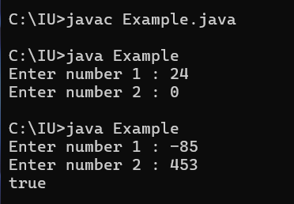

==================================Q 30 ========================================

import java.util.*;

class Coursework4{

public static void main(String args[]){

Scanner input = new Scanner(System.in);

System.out.print("Input a alphabet chracter : ");

char alpha = input.next().charAt(0);

if (alpha >= 65 && alpha <= 90){

System.out.println("It is a Uppercase letter");

}else if(alpha >= 97 && alpha <= 122){

System.out.println("It is Lowercase letter");

}else{

System.out.println("Please input a alphabet letter");

}

}

}

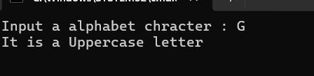

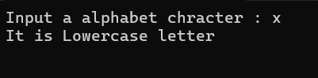

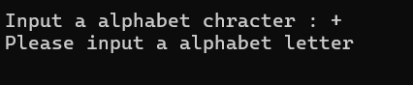

==================================Q 31 ========================================

import java.util.*;

class Example{

public static void main(String[] args) {

Scanner input = new Scanner(System.in);

System.out.print("Enter a number : ");

int number = input.nextInt();

float remainder = number % 10;

float divisible = number % 7 ;

if (remainder == 7 || divisible == 0){

System.out.printf("%d is a Buzz number", number);

}else {

System.out.printf("%d is not a Buzz number", number);

}

}

}

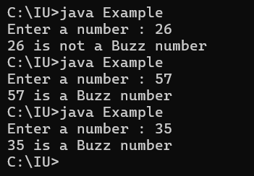

==================================Q 32 ========================================

import java.util.*;

class Example{

public static void main(String args[]){

Scanner input = new Scanner(System.in);

System.out.print("\nNumber of classes held : ");

float classes_held = input.nextInt();

System.out.print("Number of classes attended : ");

int attended = input.nextInt();

float attendence = attended / classes_held * 100;

if (attendence >= 70){

System.out.printf("\nYour attendence is %.2f%% and You are eligible for the PRF exam.\n",attendence);

}else{

input.nextLine();

System.out.print("\nDo you have medical cause('Y' OR 'N') : ");

String medical = input.nextLine();

if (medical.equals("Y")){

System.out.print("\nYou are eligible for the PRF exam.\n");

}else if (medical.equals("N")){

System.out.println("\nYou are not allowed to sit for the exam\n");

}else{

System.out.println("\nYour input is incorrect\n");

}

}

}

}

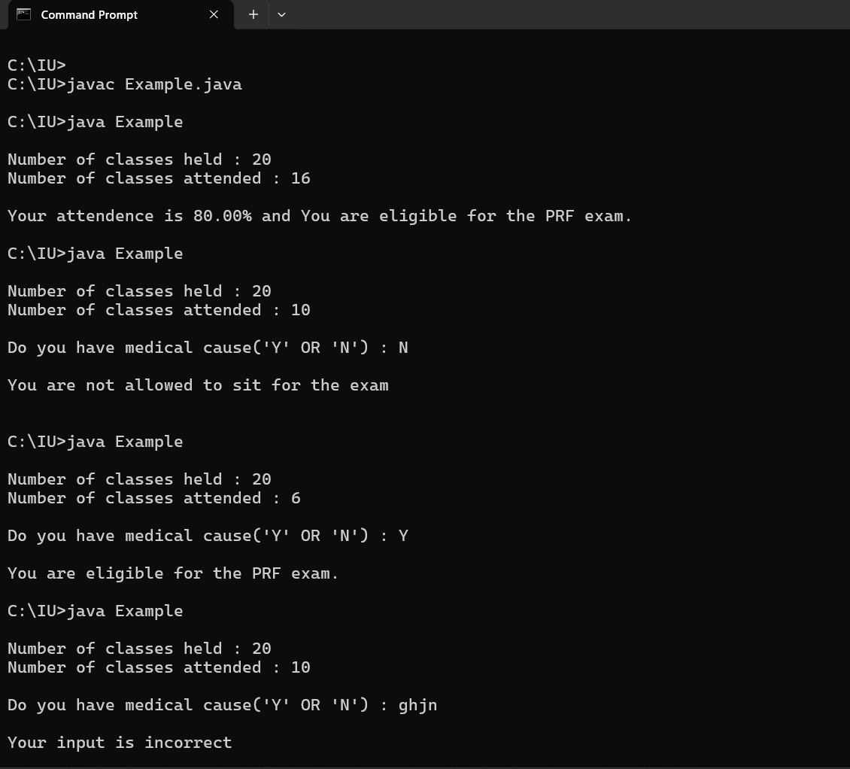

==================================Q 33 ========================================

import java.util.*;

class Example{

public static void main(String args[]){

Scanner input = new Scanner(System.in);

//input.nextLine();

System.out.print("\nAre you permenent employee('Y' OR 'N') : ");

String medical = input.nextLine();

if (medical.equals("Y")){

System.out.print("Enter the salary amount : ");

int salary = input.nextInt();

System.out.print("Enter the year of sevice : ");

int service = input.nextInt();

//total_salary = 0;

if (service < 5 ){

double total_salary = salary + salary * 10 / 100;

System.out.printf("\nYour salary with bonus = %.2f\n",total_salary);

}else if (service < 10){

double total_salary = salary + salary * 15 / 100;

System.out.printf("\nYour salary with bonus = %.2f\n",total_salary);

}else if (service > 10){

double total_salary = salary + salary * 25 / 100;

System.out.printf("\nYour salary with bonus = %.2f\n",total_salary);

}

}else if (medical.equals("N")){

System.out.println("\nYou do not have any bonus\n");

}else{

System.out.println("\nYour input is incorrect\n");

}

}

}

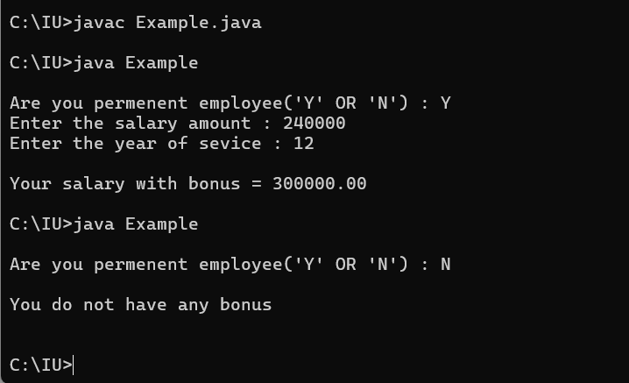

==================================Q 34 ========================================

import java.util.*;

class Example{

public static void main(String args[]){

Scanner input = new Scanner(System.in);

System.out.print("Enter the number of books : ");

int books = input.nextInt();

int cost = 100;

double total = 0;

double discount = 0;

double subtotal = books * cost;

if (subtotal > 5000){

discount = subtotal * 10 /100;

total = subtotal - discount;

System.out.printf("Subtotal: %.2f\n",subtotal);

System.out.printf("Discount: %.2f\n",discount);

System.out.printf("TOTAL : %.2f\n",total);

}else{

total = subtotal;

System.out.printf("Subtotal: %.2f\n",subtotal);

System.out.println("Discount: -");

System.out.printf("TOTAL : %.2f\n",total);

}

}

}

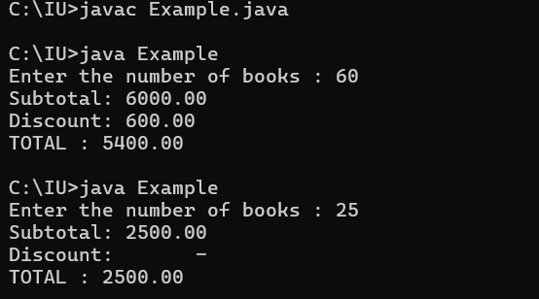

==================================Q 35 ========================================

import java.util.Scanner;

class Example{

public static void main(String args[]){

Scanner input = new Scanner(System.in);

System.out.print("Input the tempurature : ");

float temp = input.nextFloat();

if (temp >= 80){

System.out.println("Swimming");

}else if (temp >= 60){

System.out.println("Tennis");

}else if (temp >= 40){

System.out.println("Golf");

}else{

System.out.println("Skiing");

}

}

}

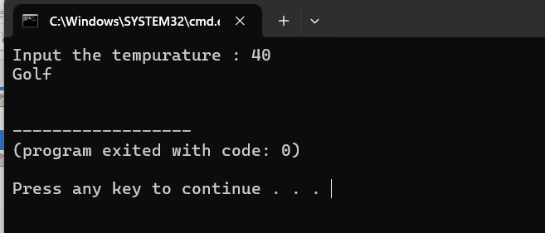

==================================Q 36 ========================================

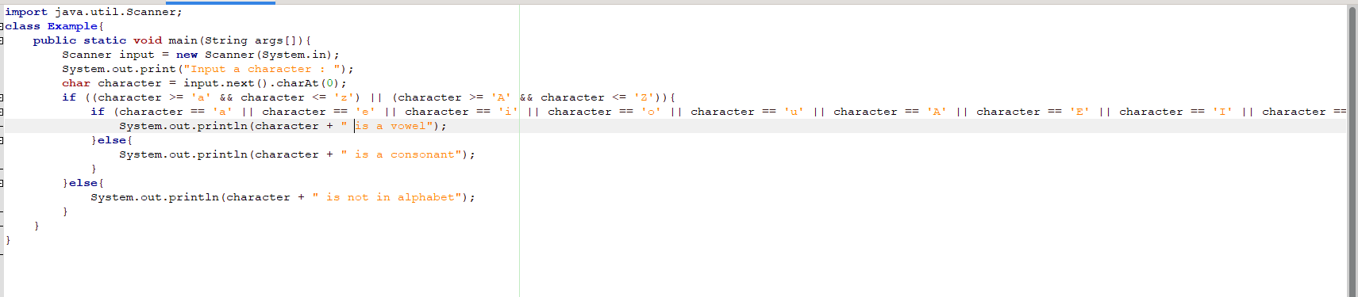

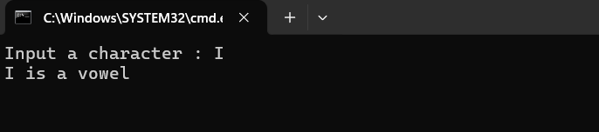

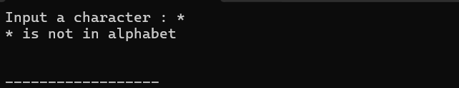

==================================Q 37 ========================================

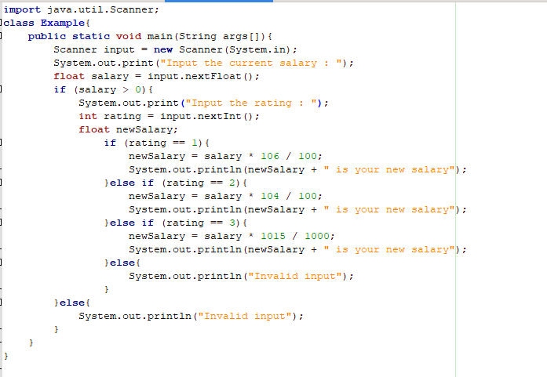

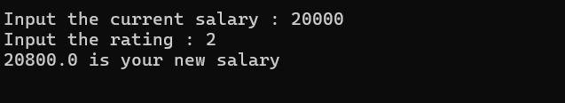

==================================Q 38 ========================================

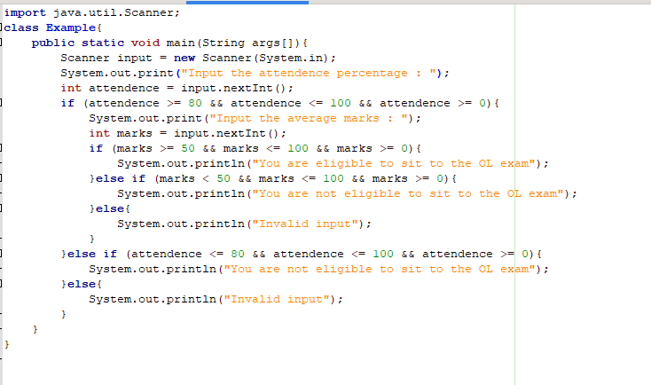

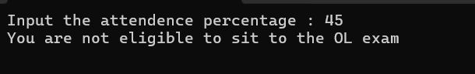

==================================Q 39 ========================================

==================================Q 40 ========================================

import java.util.Scanner;

class Example{

public static void main(String args[]){

Scanner input = new Scanner(System.in);

System.out.print("Input the year : ");

int year = input.nextInt();

if (year > 0){

System.out.print("Input month : ");

String month = input.next();

if (month.equalsIgnoreCase("january") || month.equalsIgnoreCase("march") || month.equalsIgnoreCase("may") || month.equalsIgnoreCase("jully") || month.equalsIgnoreCase("aughust") || month.equalsIgnoreCase("october") || month.equalsIgnoreCase("december")){

System.out.println("1 2 3 4 5 6 7");

System.out.println("8 9 10 11 12 13 14");

System.out.println("15 16 17 18 19 20 21");

System.out.println("22 23 24 25 26 27 28");

System.out.println("29 30 31");

}else if (month.equalsIgnoreCase("april") || month.equalsIgnoreCase("june") || month.equalsIgnoreCase("september") || month.equalsIgnoreCase("november")){

System.out.println("1 2 3 4 5 6 7");

System.out.println("8 9 10 11 12 13 14");

System.out.println("15 16 17 18 19 20 21");

System.out.println("22 23 24 25 26 27 28");

System.out.println("29 30 31");

}else if (year % 4 == 0 && month.equalsIgnoreCase("february")){

System.out.println("1 2 3 4 5 6 7");

System.out.println("8 9 10 11 12 13 14");

System.out.println("15 16 17 18 19 20 21");

System.out.println("22 23 24 25 26 27 28");

System.out.println("29 ");

}else if (month.equalsIgnoreCase("february")){

System.out.println("1 2 3 4 5 6 7");

System.out.println("8 9 10 11 12 13 14");

System.out.println("15 16 17 18 19 20 21");

System.out.println("22 23 24 25 26 27 28");

}else{

System.out.println("Invalid input");

}

}else{

System.out.println("Invalid input");

}

}

}

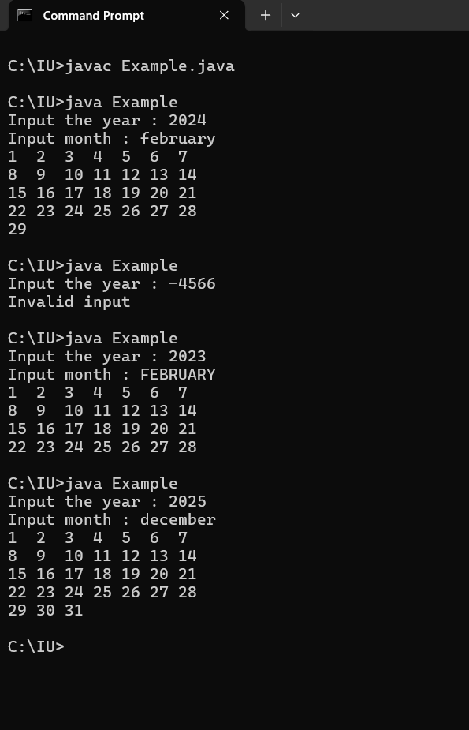

==================================Q 41 ========================================

import java.util.Scanner;

class Example{

public static void main(String args[]){

Scanner input = new Scanner(System.in);

int price;

while (true){

System.out.print("Enter the number of copies : ");

int noCopies = input.nextInt();

if (noCopies >= 0){

if(noCopies < 100){

price = 30 * noCopies;

System.out.println("Price per copy = " + 30);

}else if(noCopies < 500){

price = 28 * noCopies;

System.out.println("Price per copy = " + 28);

}else if(noCopies < 800){

price = 27 * noCopies;

System.out.println("Price per copy = " + 27);

}else if(noCopies <= 1000){

price = 26 * noCopies;

System.out.println("Price per copy = " + 26);

}else{

price = 25 * noCopies;

System.out.println("Price per copy = " + 25);

}

System.out.println("Total price = " + price);

break;

}else{

System.out.println("Invalid input");

}

}

}

}

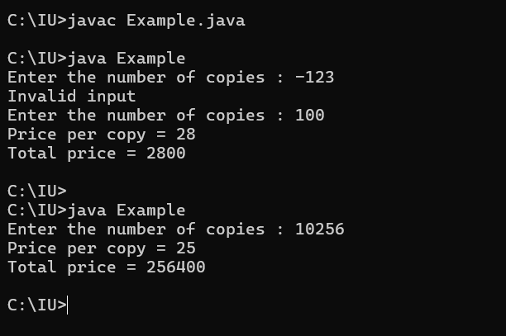

==================================Q 42 ========================================

import java.util.Scanner;

class Example{

public static void main(String args[]){

Scanner input = new Scanner(System.in);

while(true){

System.out.print("Enter the waist size(inches) : ");

int size = input.nextInt();

if (size >= 28 && size <= 42){

if (size >= 28 && size <= 29){

System.out.println("X - small");

break;

}else if (size >= 30 && size <= 31){

System.out.println("Small");

break;

}else if (size >= 32 && size <= 34){

System.out.println("Medium");

break;

}else if (size >= 35 && size <= 38){

System.out.println("Large");

break;

}else {

System.out.println("X - Large");

break;

}

}else{

System.out.println("Invalid input");

}

}

}

}

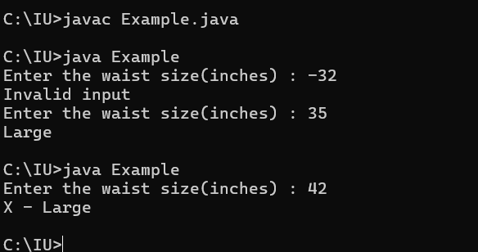

==================================Q 43 ========================================

import java.util.Scanner;

class Example{

public static void main(String args[]){

Scanner input = new Scanner(System.in);

System.out.print("Enter number 1 : ");

double num1 = input.nextDouble();

System.out.print("Enter number 2 : ");

double num2 = input.nextDouble();

System.out.print("Enter the operator : ");

String operator = input.next();

double operation;

if (operator.equals("+")){

operation = num1 + num2;

System.out.printf("%f + %f = %.2f",num1,num2,operation);

}else if (operator.equals("-")){

operation = num1 - num2;

System.out.printf("%f - %f = %.2f",num1 ,num2, operation);

}else if (operator.equals("*")){

operation = num1 * num2;

System.out.printf("%f * %f = %.2f", num1 ,num2, operation);

}else if (operator.equals("/")){

operation = num1 / num2;

System.out.printf("%f / %f = %.2f", num1, num2, operation);

}else if (operator.equals("^")){

operation = Math.pow(num1, num2);

System.out.printf("%f ^ %f = %.2f", num1, num2, operation);

}else{

System.out.println("Invalid input");

}

}

}

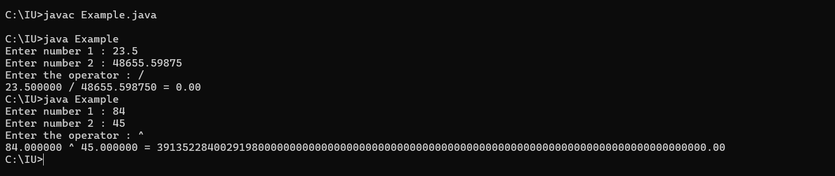

==================================Q 44 ========================================

import java.util.Scanner;

class Example{

public static void main(String args[]){

Scanner input = new Scanner(System.in);

while (true){

System.out.print("Input a number between 1 to 28 : ");

int day = input.nextInt();

if (day > 0 && day < 29){

if (day == 1 || day == 8 || day == 15 || day == 22){

System.out.println("Tuesday");

break;

}else if (day == 2 || day == 9 || day == 19 || day == 23){

System.out.println("Wednsday");

break;

}else if (day == 3 || day == 10 || day == 20 || day == 24){

System.out.println("Thursday");

break;

}else if (day == 4 || day == 11 || day == 18 || day == 25){

System.out.println("Friday");

break;

}else if (day == 5 || day == 12 || day ==19 || day == 26){

System.out.println("Saturday");

break;

}else if (day == 6 || day == 13 || day == 20 || day == 27){

System.out.println("Sunday");

break;

}else if (day == 7 || day == 14 || day == 21 || day == 28){

System.out.println("Monday");

break;

}else {

System.out.println("Invalid input");

}

}else{

System.out.println("Invalid input");

}

}

}

}

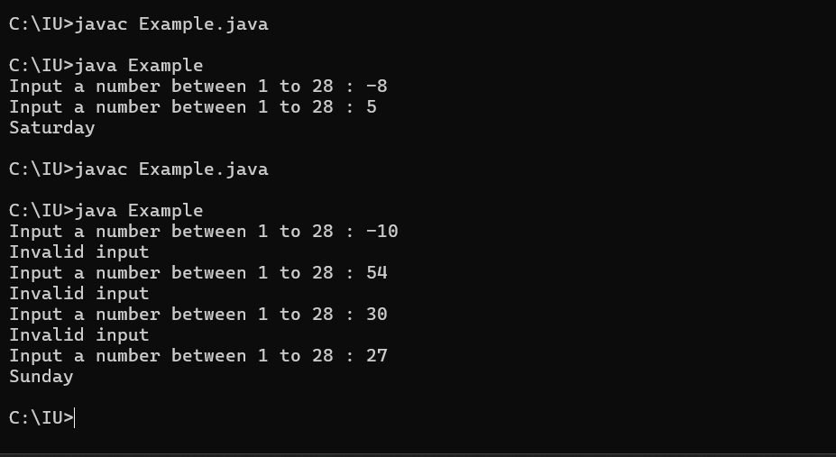

==================================Q 45 ========================================

import java.util.Scanner;

class Example{

public static void main(String args[]){

Scanner input = new Scanner(System.in);

while (true){

System.out.print("Input the column number : ");

int column = input.nextInt();

if (column > 0 && column < 9){

while (true){

System.out.print("Input the row number : ");

int row = input.nextInt();

if (row > 0 && row < 9){

if (row % 2 == 1 && column % 2 == 1){

System.out.println("white");

break;

} else if (row % 2 == 1 && column % 2 == 0){

System.out.println("black");

break;

}else if (row % 2 == 0 && column % 2 == 1){

System.out.println("black");

break;

}else{

System.out.println("white");

break;

}

}else {

System.out.println("Invalid row number. Please enter valid range number.");

}

}

break;

}else{

System.out.println("Invalid column number. Please enter enter valid range number.");

}

}

}

}

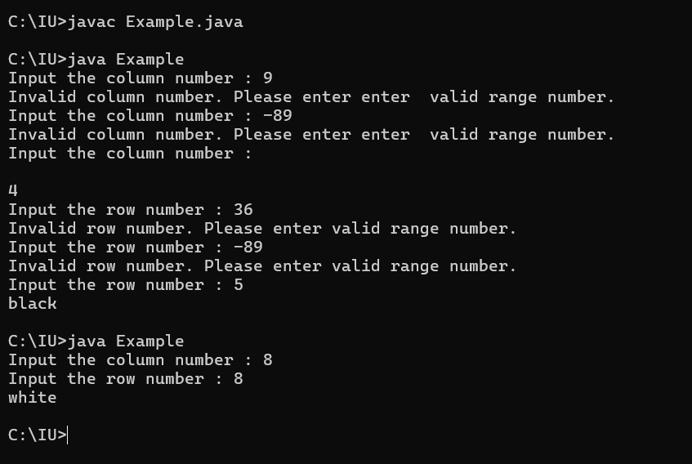

==================================Q 46 ========================================

import java.util.Scanner;

class Example {

public static void main(String args[]) {

Scanner input = new Scanner(System.in);

while (true) {

System.out.print("Input length 1 : ");

double len1 = input.nextDouble();

if (len1 > 0) {

while (true) {

System.out.print("Input length 2 : ");

double len2 = input.nextDouble();

if (len2 > 0) {

while (true) {

System.out.print("Input length 3 : ");

double len3 = input.nextDouble();

if (len3 > 0 ){

if ((Math.pow(len1, 2) + Math.pow(len2, 2) == Math.pow(len3, 2)) || (Math.pow(len2, 2) + Math.pow(len3, 2) == Math.pow(len1, 2)) || (Math.pow(len1, 2) + Math.pow(len3, 2) == Math.pow(len2, 2))) {

System.out.println("It is a Pythagorean triple.");

break;

} else {

System.out.println("It is not a Pyhtogorean triple");

break;

}

}else{

System.out.println("Invalid input");

}

}

break;

} else {

System.out.println("Invalid input");

}

}

break;

} else {

System.out.println("Invalid input");

}

}

}

}

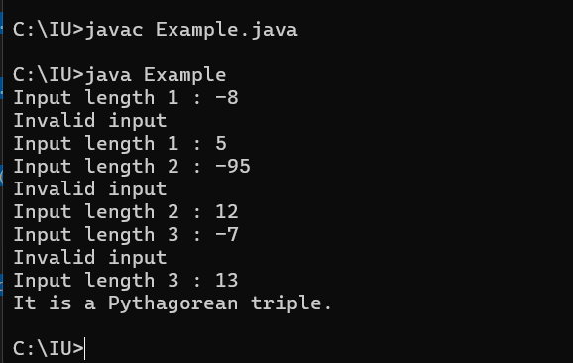

==================================Q 47 ========================================

import java.util.*;

class Week_4_assignment{

public static void main(String args[]){

Scanner input = new Scanner(System.in);

System.out.print("Input the month as integer : ");

int month = input.nextInt();

if (month > 0 && month <= 12){

if (month == 2){

System.out.print("Input the day as integer : ");

int day = input.nextInt();

if (day > 0 && day <= 29){

System.out.println("Winter");

}else{

System.out.println("Invalid input");

}

}else if (month == 1 || month == 3 || month == 5 || month == 7 || month == 8 || month == 10 || month == 12){

System.out.print("Input the day as a integer : ");

int day = input.nextInt();

if (day > 0 && day <= 31){

if((month == 12 && day >= 21) || (month == 3 && day <= 19) || (month == 1)){

System.out.println("Winter");

}else if ((month == 3 && day >= 20) || (month == 5)){

System.out.println("Spring");

}else if (month == 7 || month == 8){

System.out.println("Summer");

}else if (month == 10 || (month == 12 && day <= 20)){

System.out.println("Autumn");

}

}else{

System.out.println("Invalid input");

}

}else if (month == 4 || month == 6 || month == 9 || month == 11){

System.out.print("Input the day as a integer : ");

int day = input.nextInt();

if (day > 0 && day <= 30){

if ((month == 4) || (month == 6 && day <= 20)){

System.out.println("Spring");

}else if ((month == 6 && day >= 21) || (month == 9 && day <= 21)){

System.out.println("Summer");

}else if ((month == 9 && day >= 22) || month == 11){

System.out.println("Autumn");

}

}else{

System.out.println("Invalid input");

}

}else{

System.out.println("Invalid input");

}

}else{

System.out.println("\nInvalid input");

}

}

}

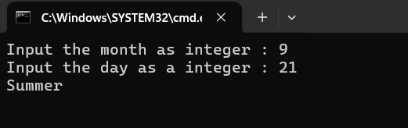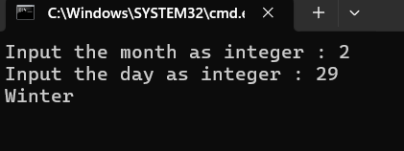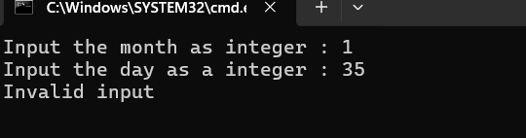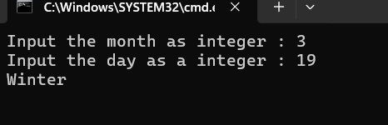

==================================Q 48 ========================================

import java.util.*;

class Week_4_Assignment_48{

public static void main(String args[]){

Scanner input = new Scanner(System.in);

System.out.print("Input the month as Integer : ");

int month = input.nextInt();

if (month > 0 && month <= 12){

System.out.print("Input the day as Integer : ");

int day = input.nextInt();

if (month == 2 && day <= 29 && day > 0){

if (day <= 18){

System.out.println("Aquarius");

}else{

System.out.println("Pisces");

}

}else if ((month == 1 || month == 3 || month == 5 || month == 7 || month == 8 || month == 10 || month == 12) && day > 0 && day <= 31){

if (month == 1 && day >= 20){

System.out.println("Aquarius");

}else if (month == 1){

System.out.println("Capricornus");

}else if (month == 3 && day <= 20){

System.out.println("Pisces");

}else if (month == 3){

System.out.println("Aries(Ram)");

}else if (month == 5 && day <= 20){

System.out.println("Taurus");

}else if (month == 5){

System.out.println("Gemini");

}else if (month == 7 && day <= 22){

System.out.println("Cancer");

}else if (month == 7 || (month == 8 && day <= 22)){

System.out.println("Leo");

}else if (month == 8){

System.out.println("Virgo");

}else if (month == 10 && day <= 23){

System.out.println("Libra");

}else if (month == 10){

System.out.println("Scorpius");

}else if (month == 12 && day <= 21){

System.out.println("Sagittarius");

}else if (month == 12){

System.out.println("Capricornus");

}

}else if ((month == 4 || month == 6 || month == 9 || month == 11) && day > 0 && day <= 30){

if (month == 4 && day <= 19){

System.out.println("Aries(Ram)");

}else if (month == 4){

System.out.println("Taurus");

}else if (month == 6 && day <= 21){

System.out.println("Gemini");

}else if (month == 6){

System.out.println("Cancer");

}else if (month == 9 && day <= 22){

System.out.println("Virgo");

}else if (month == 9){

System.out.println("Libra");

}else if (month == 11 && day <= 21){

System.out.println("Scorpius");

}else if (month == 11){

System.out.println("sagittarius");

}

}else{

System.out.println("Invalid day");

}

}else{

System.out.println("Invalid month");

}

}

}

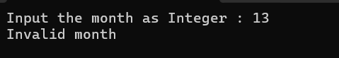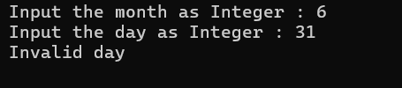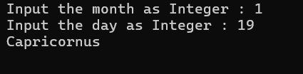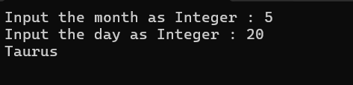

==================================Q 49 ========================================

import java.util.*;

class Week_4_assignment_49{

public static void main (String args[]){

Scanner input = new Scanner(System.in);

try{

System.out.print("Input salary : ");

double salary = input.nextDouble();

double grossSalary = salary;

if (salary >= 0){

if (salary <= 10000){

grossSalary += salary * 20.0 / 100 + salary * 60.0 / 100;

}else if (salary <= 20000){

grossSalary += salary * 25.0 / 100 + salary * 70.0 / 100;

}else{

grossSalary += salary * 30.0 / 100 + salary * 75.0 / 100;

}

}else{

System.out.println("\nInvalid input");

}

System.out.printf("Gross Salary = %.2f", grossSalary);

}catch(Exception e){

System.out.println("\nInvalid input");

}

}

}

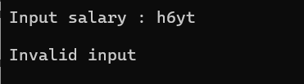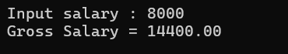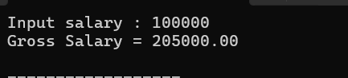

==================================Q 50 ========================================

import java.util.*;

class Week_4_assignment_50{

public static void main(String args[]){

Scanner input = new Scanner(System.in);

try{

System.out.print("Input degrees for angle 1 : ");

int angle1 = input.nextInt();

System.out.print("Input degrees for angle 2 : ");

int angle2 = input.nextInt();

System.out.print("Input degrees for angle 3 : ");

int angle3 = input.nextInt();

if (angle1 > 0 && angle2 > 0 && angle3 > 0 && angle1 < 180 && angle2 < 180 && angle3 < 180){

int total = angle1 + angle2 + angle3;

if (total == 180){

System.out.println("It is a triangle");

}else{

System.out.println("It is not a triangle");

}

}else{

System.out.println("Invalid degree range");

}

}catch (Exception e){

System.out.println("Invalid input");

}

}

}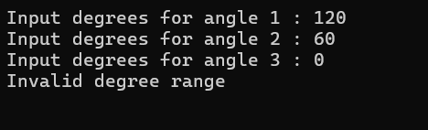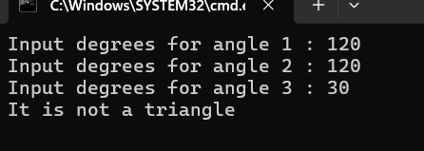

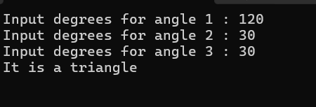

==================================Q 51 ========================================

import java.util.*;

class Week_4_assignment_51{

public static void main(String args[]){

Scanner input = new Scanner (System.in);

try{

System.out.print("Enter your age : ");

float age = input.nextFloat();

if (age > 0 && age <= 120){

if (age > 65){

System.out.println("Invalid input");

}else if (65 >= age && age > 20){

System.out.println("Adult");

}else if(20 >= age && age > 13){

System.out.println("Tenager");

}else if (13 >= age && age > 1){

System.out.println("child");

}else{

System.out.println("Infant");

}

}else{

System.out.println("Invalid input");

}

}catch (Exception e){

System.out.println("Invalid inputtt");

}

}

}

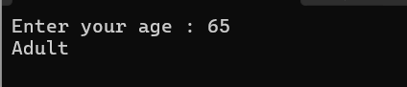

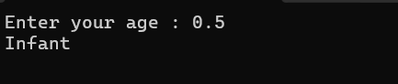

==================================Q 52 ========================================

import java.util.*;

class Week_4_assignment_52{

public static void main(String args[]){

Scanner input = new Scanner (System.in);

try{

System.out.print("Input X coordinate : ");

double x = input.nextDouble();

System.out.printw("Input Y coordinate : ");

double y = input.nextDouble();

if(x == 0 || y == 0){

System.out.println("It does not belong to any of the four quadrant");

}else if (x > 0 && y > 0){

System.out.println("Quadrant I");

}else if (x < 0 && y > 0){

System.out.println("Quadrant II");

}else if (x < 0 && y < 0){

System.out.println("Quadrant III");

}else{

System.out.println("Quadrant IV");

}

}catch (Exception e){

System.out.println("Invalid input");

}

}

}

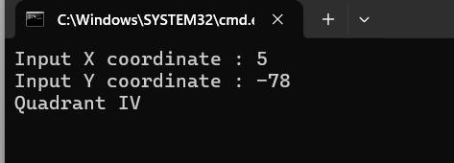

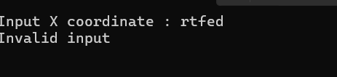

==================================Q 53 ========================================

==================================Q 54 ========================================

==================================Q 55 ========================================

==================================Q 56 ========================================

==================================Q 57 ========================================

==================================Q 58 ========================================

==================================Q 59 ========================================

==================================Q 60 ========================================